Monte Carlo method

Def

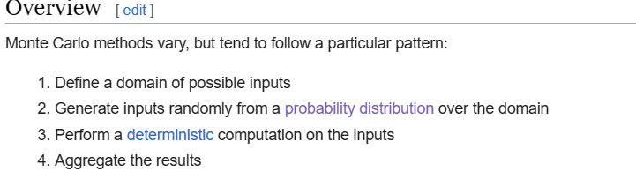

Consideration

There are important considerations.

1. Uniformly distribution for set of points.
2. NOT a few points are randomly placed in the whole square.

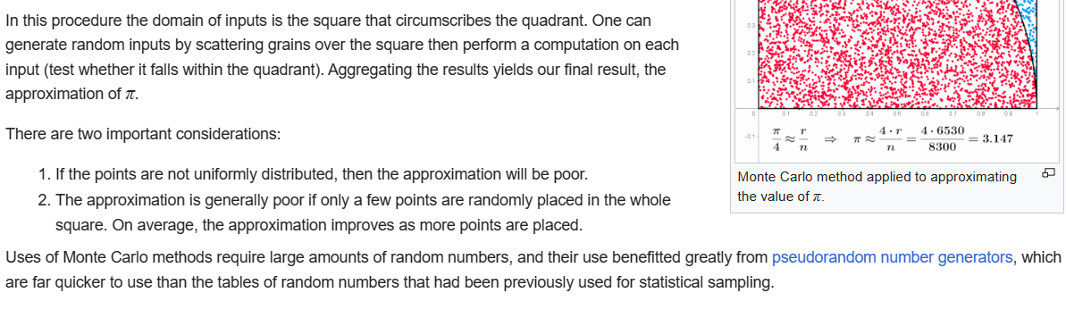

Monte Carlo stimulation v.s. ‘what if’

Scenarios

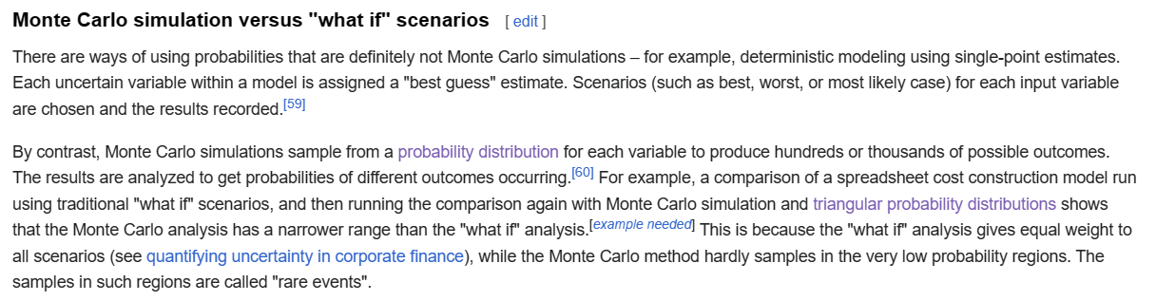

Application

Physical science

Engineering

Climate change

Radiative forcing

Computational biology

Applied statistics

Finance and business

AI

Examples

Example 1

Approximate value of $$pi\left(\right)$$, using Monte Carlo analysis.

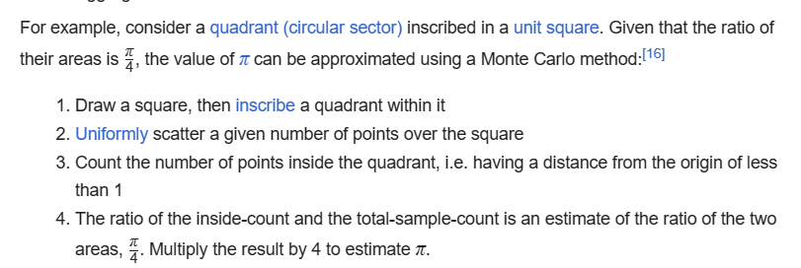

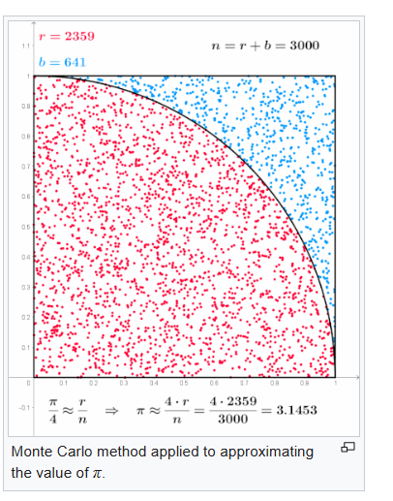

Ref

[Monte Carlo method - Wikipedia](https://en.wikipedia.org/wiki/Monte_Carlo_method)